FIT5057 Project Management

Assignment One – Deliverable 1

Monash Financial Shared Service Center

March 2025

FIT5057 Assignment 1 Writing Guide

This guide aims to support your success in Assignment 1 by providing guidance on each deliverable within the project management plan of your IT portfolio. Remember, this is a starting point – your own exploration of project management concepts and tools will further enhance your submission.

Important Reminders:

- Don't leave this for the last minute! Early feedback can help identify areas that need more detail, clarification, or critical analysis.
- Prepare for change and update, that's normal.
- The report is not just an opportunity to showcase your project planning skills but also to reflect on what you've learned through the process.
- All templates are provided. YOU should adapt it to your project's unique needs.
Key Writing Principles
1. Conceptual Understanding: Demonstrate a strong grasp of project management principles, linking them to practical applications in your IT project.
2. Justification: Clearly explain why specific methods, tools, or strategies were selected. Avoid generic statements—ground your reasoning in industry standards, best practices, or academic sources.
3. Professional Writing: Use formal, clear, and concise language. Your report should be well-structured, grammatically correct, and free of errors.
4. Visual Clarity: Use diagrams, charts, and tables where necessary to enhance readability. Ensure visuals are clearly labelled and referenced.
5. Accurate Referencing (APA 7th Edition)
All references must be cited in APA 7th style. Monash University Library provides citation guidelines here.
- Minimum of 3 references required (including at least one peer-reviewed academic source).
- References must be meaningfully integrated into your analysis, not just listed for formality.

Contents
DELIVERABLE 1: Project Integration Management [20%]
Business Justification
Project Charter
References
Financial Exhibits

DELIVERABLE 1: Project Integration Management (Individual Submission)

Project Title: [Monash Financial Shared Service Center]
Student Name: [Siyuan Liu]
Student ID: [35649917]
Date: [22/03/2025]

Business Justification

1.1 Strategic Alignment

1.1.1 Background
Portfolio Goals: [This project supports Monash University’s mission by modernizing financial operations, enhancing transparency, and supporting service timely through a unified Financial Shared Service Center (FSSC). It is based on SaaS, not only SaaS. Otherwise, FSSC aligns with the University’s strategic priorities of digital transformation, sustainability, and global excellence, while also supporting UN SDG 8 by promoting decent work and economic growth through improved financial systems and risk management.]
Client Context: [Monash University is a public research university based in Melbourne, Victoria, Australia. Named after World War I general Sir John Monash, it was founded in 1958 and is the second oldest university in the state. Monash is a member of Australia's Group of Eight research universities, a member of the ASAIHL, and the only Australian member of the M8 Alliance of Academic Health Centers, Universities, and National Academies]

1.1.2 Project Alignment
[Party B proposes developing a unified FSSC integrating Data Integration, Work Flow, AI Knowledge Base, Salary, Reimbursement, Travel Expense, Research Expense, Payable, and Receivable modules via an advanced IT platform, supported by a mobile app for visual tracking and automated workflows]
Strategic Goal Connection: [Improving Productivity & Efficiency (SDG 8.2 & 8.4):
The FSSC will leverage technological upgrades and automation, optimizing resource use and reducing manual errors.
Enhancing Employment & Work Quality (SDG 8.3 & 8.5):
The centralized model supports job specialization, creating opportunities for financial professionals to develop new skills and focus on higher-value tasks.

Strengthening Financial Systems & Access (SDG 8.10):
The FSSC will consolidate financial transactions across departments, eliminating data silos and reducing the risk of fraud, errors, and unauthorized transactions;
By integrating advanced biometric authentication mechanisms and encrypted transactions, FSSC will provide safe, user-friendly financial access to all staff members.

Thriving Communities & Sustainable Development (Monash Strategic-Plan-2023):
The FSSC will eliminate inefficiencies and optimize financial resource allocation, allowing Monash to invest in research, education, and sustainability initiatives.

Digital Transformation & Innovation (Monash Strategic-Plan-2023):
The platform integrates AI-driven financial insights and real-time data analytics, aligning with Monash’s goal of leveraging technology for efficiency and decision-making. “AI has the potential to enhance these efforts by providing data-driven insights into community needs and offering scalable solutions. For example, AI tools can analyse social, economic, and health data to identify underserved populations and recommend interventions. This enables universities to target their outreach programmes more effectively and measure the economic impact of their initiatives (Siau & Wang, 2020)”.

Global Excellence & Collaboration (Monash Strategic-Plan-2023):
FSSC enables cross-departmental collaboration, ensuring transparency and data-driven decisions that support Monash’s international research and educational partnerships.]

1.1.3 Current Situation and Problem/Opportunity Statement
Problem: [Monash University is a globally recognized educational institution committed to academic excellence, research innovation, and sustainable development. With expanding operations and an evolving structure, its traditional financial systems have become a bottleneck. Decentralized financial processes and outdated systems create information silos, duplicate efforts, delay decision-making, and expose the University to heightened financial risk]
Opportunity: [Centralizing operations into a unified FSSC offers streamlined processes, enhanced transparency, and improved risk management, directly advancing strategic digital transformation and operational efficiency.]

Value Delivery: [
Quantitative Benefits:
- Cost Savings: By reducing the data workload of finance staff—especially during complex tasks like year-end tax filing—the FSSC minimizes labor cost. To give a example: ”Total spending in English local authorities over the period 2008–16 increased in real-terms7 from 2008 to 2010, then fell by about 17% from 2010 to 2016. Total employee costs fell by about 30% in real terms from 2010 to 2016, while total nonemployee (“running”) costs fell by 7%. The category of Management and Support Service spending (M&SS, used to calculate AI) showed similar trends to total expenditure, falling about 20% in real terms from 2010 to 2016.(T Elston, R Dixon, 2020)”
- Efficiency Gains: The platform’s capabilities for fast deployment, elastic scaling, fault isolation, and automated operations (including API management, microservices governance, and performance monitoring) lead to significant time savings and improved system performance.

Qualitative Benefits:
- Enhanced User Experience: Visualized workflows for tracking fund flow and approvals provide real-time insights, boosting responsiveness and overall user satisfaction.
- Environmental and Traceability Improvements: Digitizing business processes reduces carbon emissions and creates an auditable work trail, facilitating effective incident analysis.
- Reputation and Competitive Advantage: A modern, robust financial system reinforces Monash's image as a leader in digital innovation, attracting prospective students and encouraging further investments from the government and private sectors.
- International Standing: Achieving a digital campus not only improves operational efficiency but also elevates Monash’s global reputation, positioning it as a forward-thinking, technology-driven institution.

Overall, the FSSC is a strategic investment that not only resolves current operational inefficiencies but also positions Monash for sustainable long-term growth and enhanced international prestige.]

1.2 Cost and Benefits Analysis
[A detailed cost-benefit analysis (see Exhibit 1.1 & Exhibit 1.2) estimates an NPV of AUD 44.16 million and an ROI of 130% over 5 years(see Exhibit 2), using an 8% discount factor. The projected benefits include significant operational cost reductions and efficiency improvements, attracting more students to sign up and attract external cooperation and investment, and validating the investment in the FSSC project.]

Project Charter

2.1 Project Title & Description
[Project Title:
Monash Financial Shared Service Center (FSSC) & Mobile App (Monash AIO)
Project Description:
This project aims to develop an integrated SaaS system for Monash University that
consolidates financial operations (Salary, Reimbursement ,Business Travel, Integration Service, Work Flow Service, Payable, and Receivable modules) into a unified platform. Accompanied by a dedicated mobile app (Monash AIO), the solution will streamline processes, enhance transparency, and support automated workflows. The portfolio includes Pre-sales Research, Pre-sales Technical Evaluation, Implementation, Development, Data Integration, Testing, and Mobile app Development.
Team Member Cost Responsibilities:
Senior Technical Project Manager: Oversees overall project coordination and technical strategy. Costs include senior-level salary, benefits, and performance rewards.
SaaS Developer: Responsible for software deployment, data integration, testing, and customized development tasks. Costs are determined fixed-contract basis.
SaaS Technical Consultant: Provides technical guidance, troubleshooting, and quality assurance. Costs include a one-time higher consultant salary.
Senior Implementation Project Manager: Manages implementation activities, stakeholder coordination, and project delivery. Costs include senior managerial salary, benefits, and performance rewards.
SaaS Functional Consultant: Aligns SaaS functionalities with business processes through customization. Costs are determined one-day basis.
Mobile Apps Developer: Customize the content required by customers under the framework of the company's existing mobile app. Costs are determined one-day basis.]

2.2 Project start and end dates
[Project Start Date: 3 March 2025
Project End Date: 3 June 2026
Duration: 15 months
Key Milestones:
Project Planning & Requirements Finalization (End of May 2025)
Sandbox Environment Deployment (June 2025)
Mobile APP (Monash AIO) Developing (End of January 2026)
Pilot Implementation & Customized Developing & Unit Test (End of February 2026)
SIT Test (End of March 2026)
UAT Test & User Training (End of April 2026)
Production Environment Deployment & New System Online (June 2026)
Project Acceptance and Handover (End of June 2026)]

2.3 Project Objectives
[Objective 1: Implement FSSC that reduces manual financial processing time by 30% and human resources cost by 12% approximately (SDG 8.2 & 8.4).
Objective 2: FSSC can be in the normal online state for at least 347 days a year, and can be switched to the slave machine within 1min in case of emergencies. This fits the value of Digital Transformation & Innovation in Monash Strategic plan-2023(excluding force majeure factors such as natural disasters, the interpretation right shall be explained by Party B).
Objective 3: In the event of a sudden system outage, users can have local memory of the business they are operating, and transaction compensation will be triggered after the system is restored to ensure data consistency. This mechanism will support SDG 8.10.
Objective 4: Compared to previous business processes, Monash AIO was able to achieve more than 90% user satisfaction (SDG 8.3 & 8.5).]
2.4 Project Development Approach
[Party B will adopt an Agile project management approach. This method allows for iterative development, continuous stakeholder feedback, and risk mitigation. Agile is justified by its flexibility to adapt to evolving requirements and its proven effectiveness in digital transformation projects.]
2.5 Main Project Success Criteria
[Operational Efficiency: 30% reduction in processing time.
System Reliability: 95% uptime across all modules.
User Satisfaction: Achieve a 90% satisfaction rate among staff users.
Financial Impact: Demonstrate an ROI of at least 100% within 5 years post-implementation.]

Roles and Responsibilities
Role in the project | Name | Position in the organisation/contract | Contact Information
Senior Technical Project Manager | Siyuan Liu | Technical Director of Project Department One (organisation) | SiyuanLiu@xxx.com
SaaS Developer | Amelia Robinson | Junior Development Consultant (contract) | Amelia Robinson@yyy.com
SaaS Developer | Oliver Johnson | Junior Development Consultant (contract) | Oliver Johnson@yyy.com
SaaS Developer | Chloe Thompson | Junior Development Consultant (contract) | Chloe Thompson@yyy.com
SaaS Technical Consultant | Grethel Rudis | Senior Technical Consultant (organisation) | Grethel Rudis@xxx.com
Senior Implementation Project Manager | Jame Smith | Implementation Director of Project Department One (organisation) | Jame Smith@xxx.com
SaaS Functional Consultant | Olivia Brown | Junior Implementation Consultant (organisation) | Olivia Brown@xxx.com
SaaS Functional Consultant | Ethon Wilson | Junior Implementation Consultant (organisation) | Ethon Wilson@xxx.com
Mobile Apps Developer | Jean Dupont | Mobile Development Consultant(organisation) | Jean Dupont@xxx.com

Sign-off: (Stakeholders sign by their names in the table above.)

Comments:




References
United Nations. (2015). Goal 8 | Department of Economic and Social Affairs. Sustainable Development Goals 8. https://sdgs.un.org/goals/goal8
Monash. (2014). Impact 2023. Strategic-plan-2030. https://www.monash.edu/__data/assets/pdf_file/0009/2680389/Strategic-Plan-2030.pdf
© Copyright Hays plc 2025. (2024). Salary Guide FY24/25. Hays Specialist Recruitment job employment agency. https://www.hays.com.au/
© Copyright Hays plc 2025. (2024a). Hays Technical Contractor Rates Guide. Hays Specialist Recruitment Job Employment Agency. https://www.hays.com.au/
Yusuf, J. A., & Ibrahim, M. A. The Economic Impact of Artificial Intelligence in Enhancing Teaching, Learning, Research, and Community Service in Higher Education.
Elston, T., & Dixon, R. (2020). The effect of shared service centers on administrative intensity in English local government: A longitudinal evaluation. Journal of Public Administration Research and Theory, 30(1), 113-129.

Financial Exhibits
Exhibit 1.1: Cost-Benefit Analysis & Conclusion
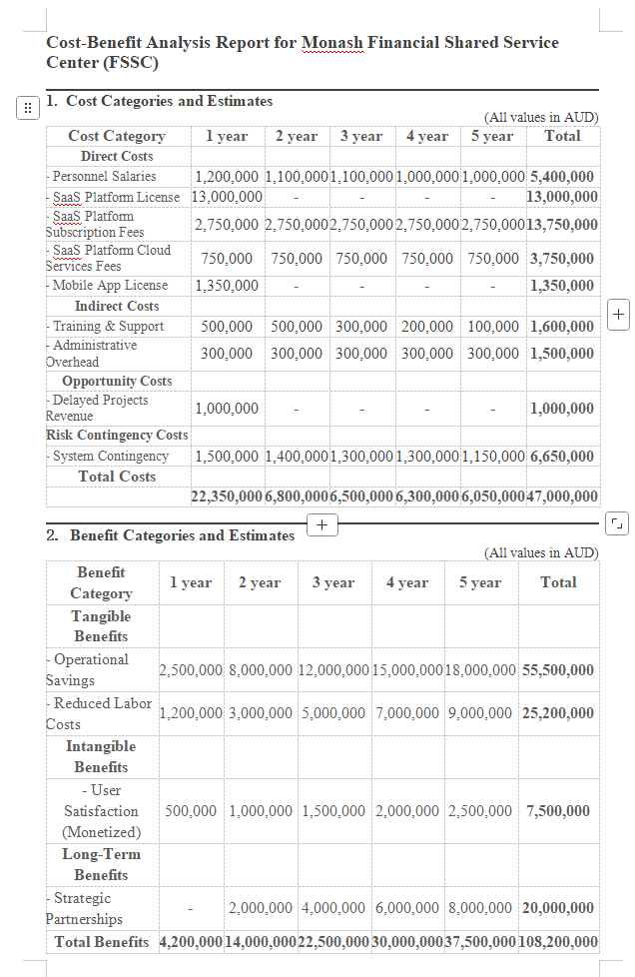

Exhibit 1.2: Cost-Benefit Analysis & Conclusion

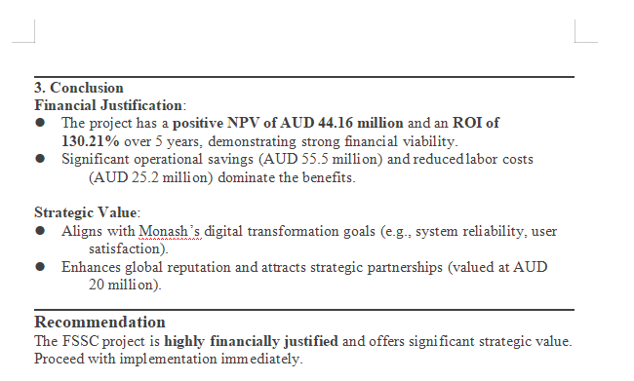

Exhibit 2: Detailed Analysis of NPV, ROI
